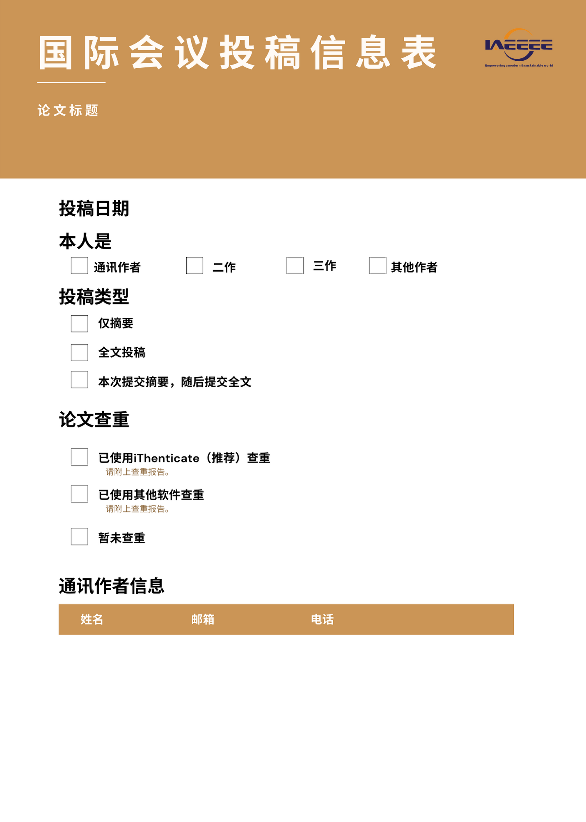

✓

✓

|  |  |  |
| --- | --- | --- |
|  |  |  |

✓

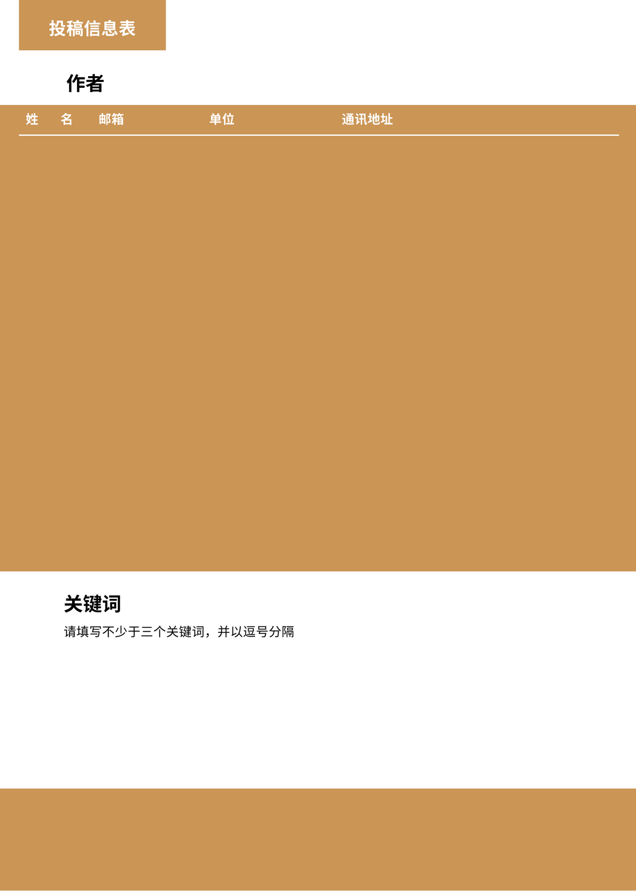

**国际电气，电子和能源工程协会**



|  |  |  |  |  |
| --- | --- | --- | --- | --- |
|  |  |  |  |  |
|  |  |  |  |  |
|  |  |  |  |  |
|  |  |  |  |  |
|  |  |  |  |  |

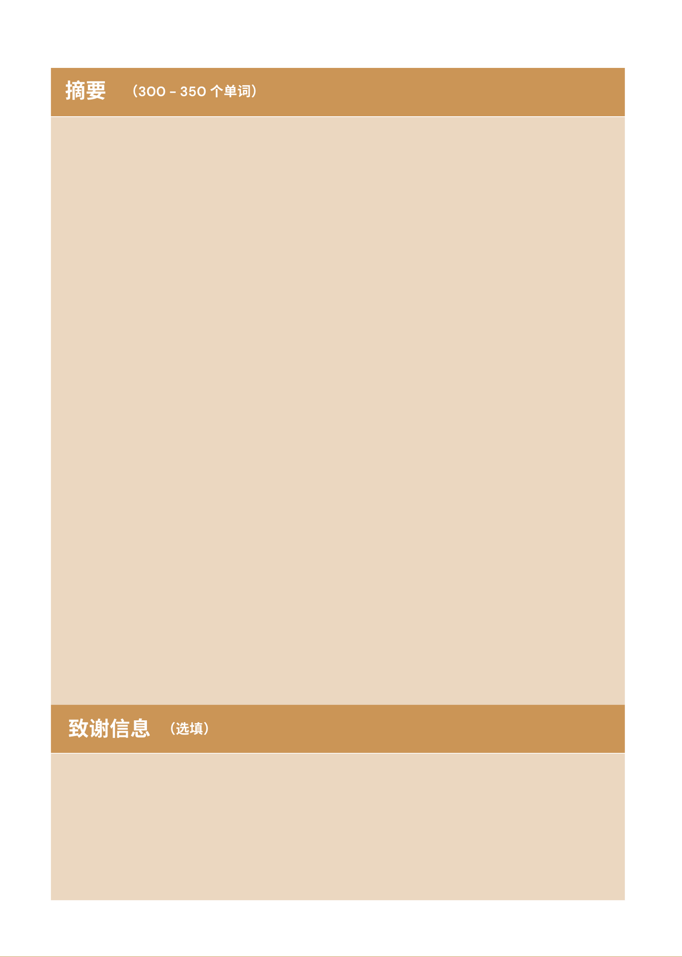

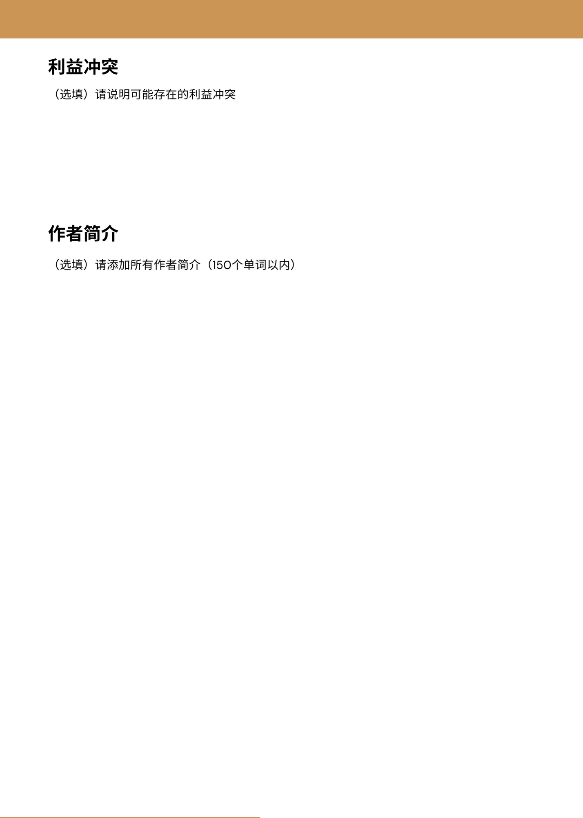

|  |  |
| --- | --- |
| **姓名** | **简介** |
|  |  |
|  |  |
|  |  |
|  |  |
|  |  |

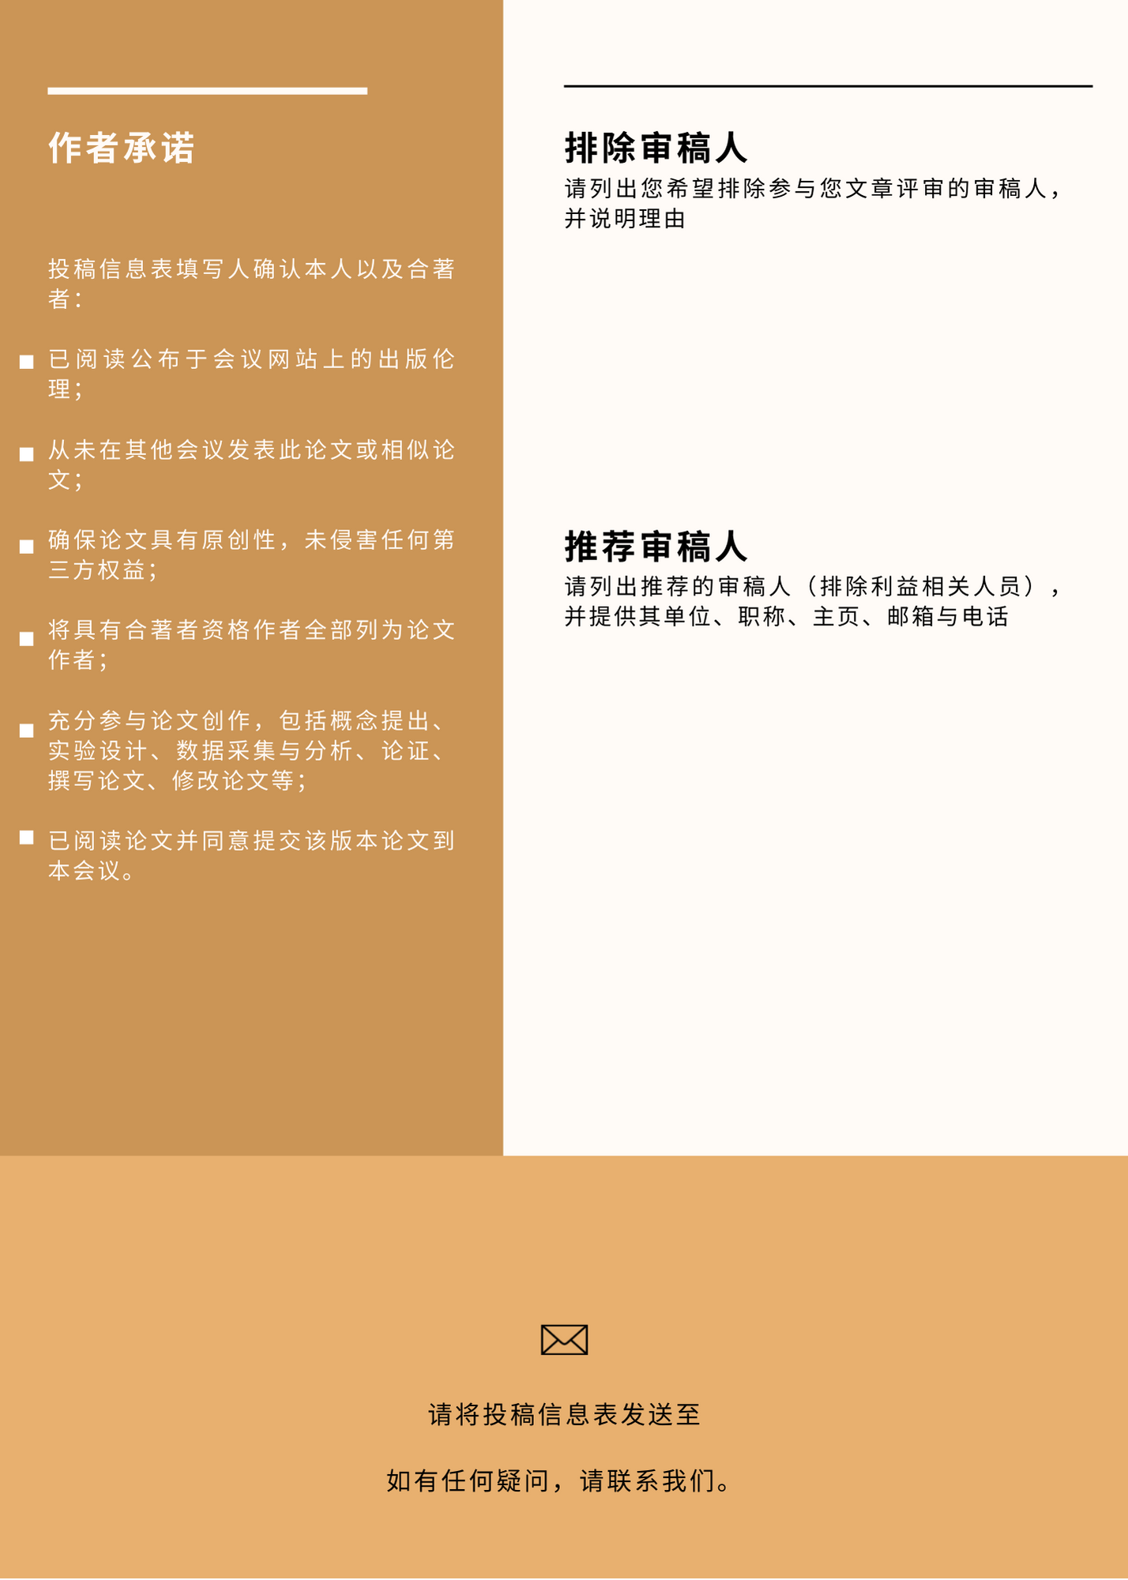

[contact@coeee.org](mailto:contact@coeee.org)